DC MOTOR CONTROL

Palko Nandor – Robert

Contents

1. Project Subject 3
2. Design Principles 3
2.1. Electrical Design 3
2.1.1. Description of components 3
2.1.2. Electrical Schematic and Physical Assembly 5
2.2. Software Design 7
2.2.1. Implementation of the Number of Rotations 7
2.2.2. Implementation of Reverse Rotation. PID Controller Design 7
2.2.3. Calculation of Motor Speed and Angular Position 9
2.3. Design of the GUI 9
3. Observations and Possible Improvements 12
4. Bibliography 12

Project Subject

The following control problem involving a DC motor is to be addressed: The motor is required to perform a specified number of rotations in a given direction, as defined by user input, followed by a reverse rotation to reach a predetermined initial position. It is essential that the user has the ability to adjust the motor speed in real-time throughout the execution of the rotations. The implementation of a User Interface is proposed to facilitate user interaction. This interface must be capable of continuously monitoring and displaying the motor’s speed and position throughout the execution of the control sequences associated with the motor.

Design Principles

Electrical Design

Description of components

The components used for this project are:
- Variable power supply 1-15V
- GA12-N20 DC motor with integrated encoder and 1:15 gearbox
- Motor Drive TB661 2FNG
- 2 buttons (for speed adjustment)
- 2 resistors of 10kΩ
- Atmega32 microcontroller mounted on an Arduino interface
The encoder will be used to read the position of the output shaft, making it possible to also calculate the motor speed. The encoder mounted on this motor consists of 14 magnets and 2 Hall sensors, providing a maximum of 28 pulses for one rotation of the motor shaft. Therefore, with a transmission ratio of 1:15, 420 pulses will be recorded for each rotation of the output shaft. Based on experimental measurements, it was found that the transmission ratio has a tolerance margin of ±1.6%, with the actual ratio of the model used being 1:14.75. This causes the number of pulses to decrease to 413. Therefore, to accurately determine position and speed, 413 pulses per rotation will be used as a reference.
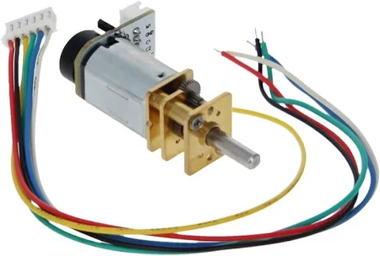

Figura 1. GA12-N20 DC Motor with encoder
The Motor Driver allows control of the DC motor in both directions due to an integrated H-Bridge. The supply voltage for the H-Bridge is provided directly from the power source supplying the motor, which is set to 9V. Additionally, the module allows speed adjustment through a PWM signal applied to the base of a transistor connected to the H-Bridge, enabling variation of the voltage drop across the motor from the bridge. The H-Bridge receives two control signals from the microcontroller (AI1, AI2), thereby dictating the desired direction: one channel is for the counterclockwise direction, and the other channel is for the clockwise direction. The standby pin must always be kept HIGH for the motor to function. The output voltage applied to the motor is established through the AO1 and AO2 pins.
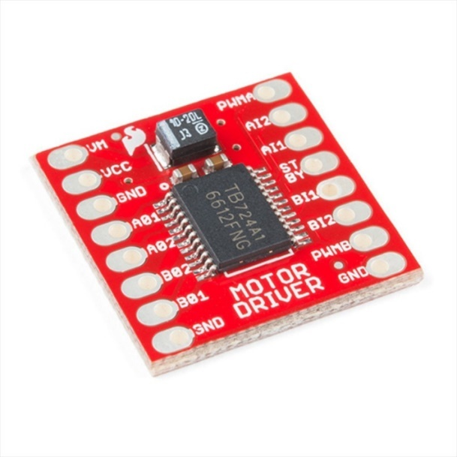

Figure 2. TB661 2FNG Motor Drive

The buttons, along with the resistors, will be connected in such a way that when pressed, pins 6 and 7 are set to HIGH. Activating these pins will result in increasing or decreasing a parameter associated with the duty cycle of the PWM control signal for the motor speed. The purpose of the resistors is to prevent potential short circuits that could occur when the buttons are pressed.
The variable power supply is capable of converting the 220V AC voltage into a 12V DC voltage through a full bridge rectifier. The signal obtained from the full bridge rectifier is applied to the terminals of a large-capacity capacitor to smooth the alternating half-cycles resulting from rectification, thus transforming it into a continuous signal. This signal is then applied to the input of an LM317 voltage regulator, which has a minimum reference voltage of 1.2V. Using a potentiometer, the reference voltage of the regulator can be adjusted, thereby varying the output voltage between 1.2V and 12V. For this application, a supply voltage of 9V will be used for the motor. Additionally, the power supply includes a Low Pass Filter for circuit protection, indicator LEDs for monitoring the power supply’s status (Power, Signals, High, Low), and a buzzer that activates in case of overloading.
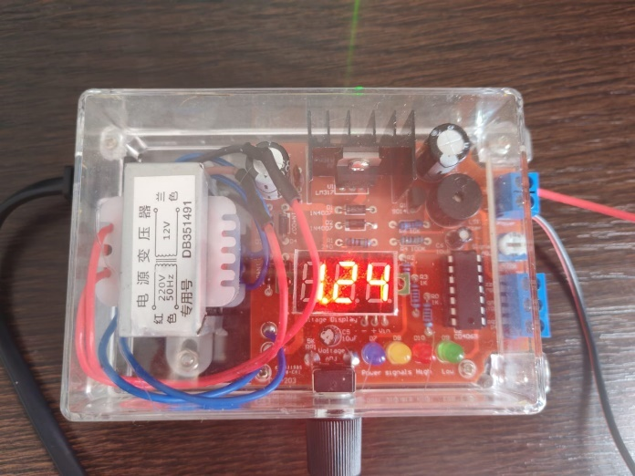

Figure 3. Voltage source

Electrical Schematic and Physical Assembly

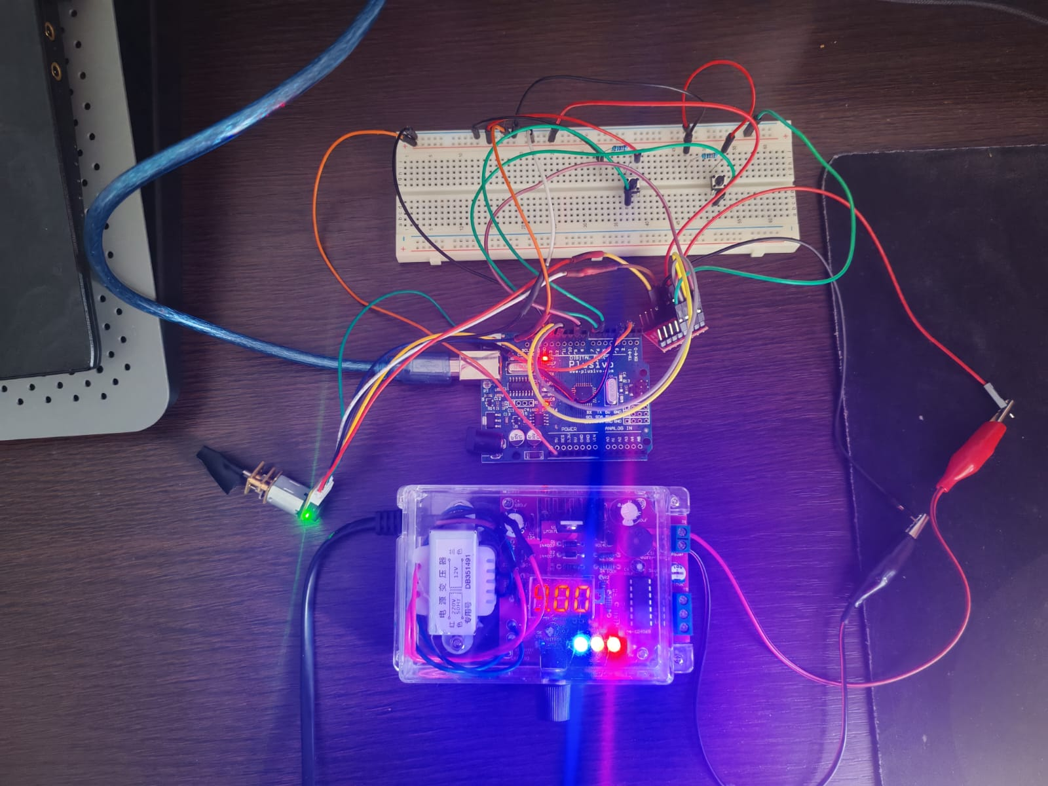

Figure 4. Physical assembly
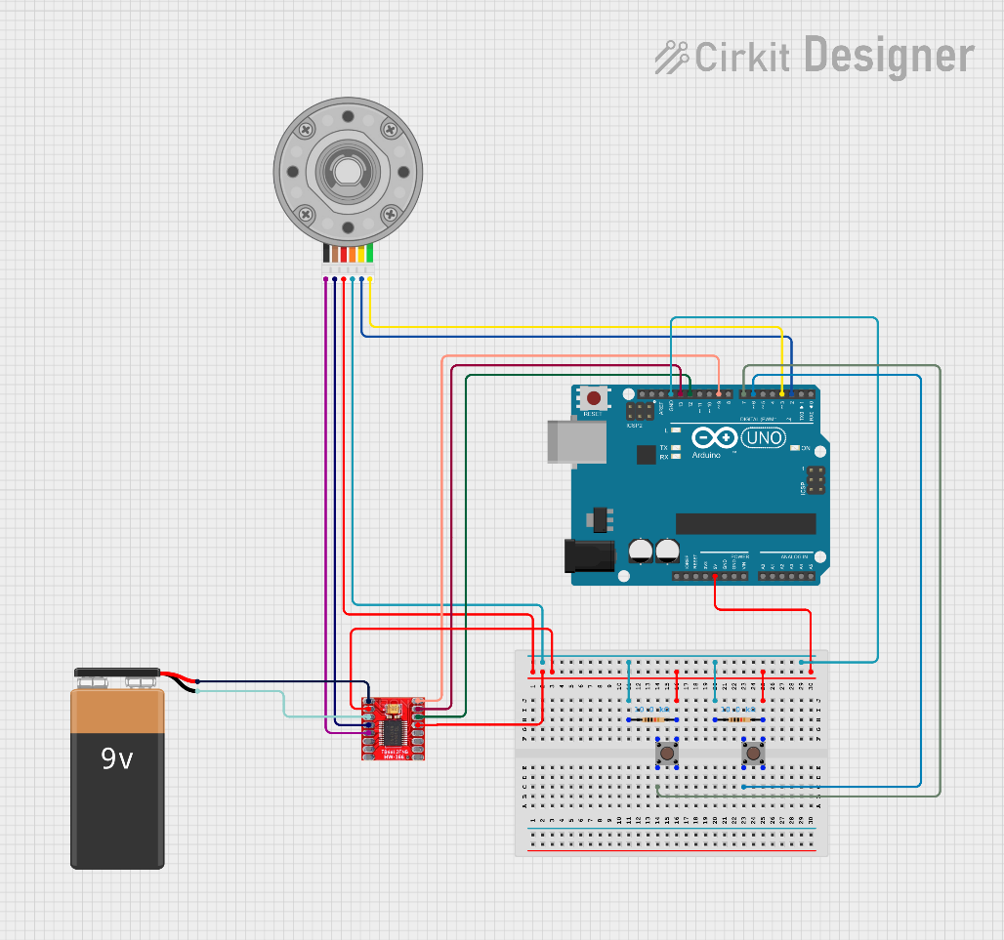

Figure 5. Electrical schematic

Pin connections:
- The Breadboard is powered with 5V from the power supply pins of the Arduino module.
- The buttons are connected to pins 6 and 7.
- The VCC and GND pins of the encoder are connected to the power supply established on the breadboard.
- The same procedure applies to the VCC and GND power pins of the Motor Driver.
- The Encoder A and Encoder B pins are connected to pins 2 and 3 (these pins enable the interrupt service routine functionality of the microcontroller).
- The AI1 and AI2 pins are connected to pins 12 and 13.
- The PWMA pin is connected to pin 9 (allowing the transmission of PWM signals).
- The AO1 and AO2 pins are connected to the motor’s power supply.
- The VM and GND pins on the Motor Driver are connected to the power supply voltage.
- The STBY pin is connected to VCC to ensure the motor operates at all times.

Software Design

Implementation of the Number of Rotations
The motor’s operational logic will be implemented using the Arduino IDE development environment. The objective is to establish a method for determining the number of pulses provided by the encoder for a complete rotation. To achieve this, an interrupt routine will be employed so that each detected pulse increments a counter that monitors the number of detected pulses. Thus, upon each HIGH detection of pins 2 and 3, the interrupt routine will be triggered, and the counter will increment each time this routine is called. By having access to two Hall sensors, it is possible to determine which sensor triggers its interrupt routine first, thereby providing information about the direction in which the motor shaft is rotating. A convention will be established: if the motor rotates counterclockwise, the counter will increment, and if it rotates clockwise, the counter will decrement. Additionally, a function will be implemented to detect the 413th pulse. After 413 pulses, the counter will reset, thereby marking the completion of one full rotation. This logic allows the user to input an unlimited number of reference rotations.
From the perspective of the reverse direction, resetting the counter is not desired to ensure clear and continuous values for position control using a controller. If the counter were to be reset, the real information regarding the error that the designed controller needs to regulate would be lost.
Having implemented functions for counting and resetting the counter after a complete rotation, it is now possible to compare the number of completed rotations with the reference number of rotations provided by the user. A new variable, “countRotations”, is introduced, initially set to 0. Each time the 413th pulse is detected, countRotations increments by 1. When countRotations reaches the reference value, the code sequence for reverse rotation is triggered. The pins are configured as follows to achieve counterclockwise rotation: AI1 = HIGH and AI2 = LOW.
It is worth mentioning that, for better positioning control in subsequent iterations, once all sequences have been completed, the program retains the last achieved position value, which is usually the initial position.

Implementation of Reverse Rotation. PID Controller Design

Once the reference number of counterclockwise rotations has been reached, the next program sequence of the application can be initiated, namely the reverse rotation of the motor and stopping it at its initial position.
An initial approach to this problem was to set AI1 = LOW and AI2 = HIGH to force the motor to rotate in the reverse direction, checking whether the initial target position was reached, and stopping the motor upon reaching that position. Although this approach was simple and quick, it did not yield accurate and precise results, resulting in a large error. Therefore, the solution of implementing a PID controller (Proportional, Integral, Derivative) was adopted.
Implementing such a controller eliminates the need for forcibly setting the motor’s rotation direction, as precise control requires the ability to rotate in both directions. Therefore, to ensure continued reverse rotation, the reference value for the control system will be set as a negative value. Since only positive values are obtained from the counterclockwise direction, setting a negative reference value will ensure that the control signal from the controller to the process (motor) is negative. This effectively establishes the motor’s rotation direction as opposite to the previous one.
The general form of a PID controller is:
$$u\left(t\right)=K_{p}e\left(t\right)+K_{i}\int_{0}^{t}{e\left(t\right)dt}+K_{p}\frac{de(t)}{dt} (1)$$
where:
- u(t) is the control signal applied to the motor.
- e(t) is the error signal, defined as the difference between the reference value and the measured value
- Kp​ is the proportional gain, which determines the response to the current error
- Ki​ is the integral gain, which determines the response based on the accumulation of past errors
- Kd​ is the derivative gain, which determines the response based on the rate of change of the error
The general form of a PID controller in the Laplace domain is:
$$u\left(t\right)=K_{p}e\left(t\right)+K_{i}\frac{1}{s}+K_{p}s (2)$$
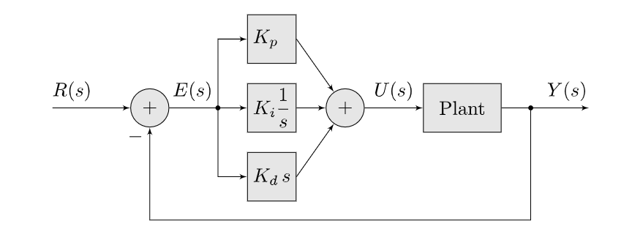
Thus, using equation (2), the structure of a process control system with a PID controller is presented in Figure 6:

Figure 6. PID Closed-Loop control
The influence of the parameters Kp, Ki, Kd are as follows:
- Kp – Proportional constant: Influences the response time of the process but does not ensure zero steady-state error.
- Ki – Integral constant: Ensures zero steady-state error but increases oscillations and response time.
- Kd – Derivative constant: Reduces the oscillations introduced by the integrator but increases the overshoot of the response.
For the software implementation of the controller, the general transfer function of a PID controller will be used, expressed in the discrete domain through recursive finite difference equations to calculate the control error at each sampling step. Previous calculation steps will be stored, and the control signal characteristic will be updated at each iteration of the main program. The parameters Kp​, Ki​, and Kd​ will be set appropriately for the system to achieve fine-tuned control, a minimal response time, and minimal oscillations. It was observed that the system exhibits oscillations with a relatively small overshoot, and the response time is a few seconds. This indicates that the motor reaches its initial position within a few seconds with minimal oscillations.

Calculation of Motor Speed and Angular Position

It is known that speed is the variation of position over a unit of time. Therefore, it can be calculated over a period of one second by determining the difference between the current position and the previous position, thereby obtaining information about the angular speed per second.:
$$RPM=\frac{angularVelocity}{PPR}*60 (3)$$
where:
- RPM – rotations per minute
- angularVelocity – angular velocity calculated before
- PPR – number of impulses in one rotation
To determine the exact angular position of the shaft (in degrees), the following formula was used:
$$angle=\left(encoderCounter\%PPR\right)*\frac{360}{PPR} (4)$$

Design of the GUI

For this application, a Graphical User Interface (GUI) was designed using the Processing development environment..
The purpose of this GUI is to enable control and retrieval of information about the state of the designed system, specifically providing details about position, speed, and the number of completed rotations.
A serial communication was established between the Arduino IDE interface and the Processing development environment, with a transmission rate of 9600 baud. Through this interface, the user can transmit rotation reference values to the Serial Monitor in the Arduino IDE. The program is designed such that the system waits for values entered by the user, only starting execution once the necessary information has been received. After completing all sequences, the program waits for a new value from the user regarding the reference number of rotations. The graphical interface is presented in Figure 7, along with some examples from the program's operation.
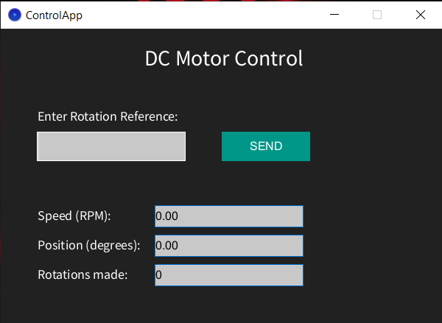

Figure 7. Grafical User Interface

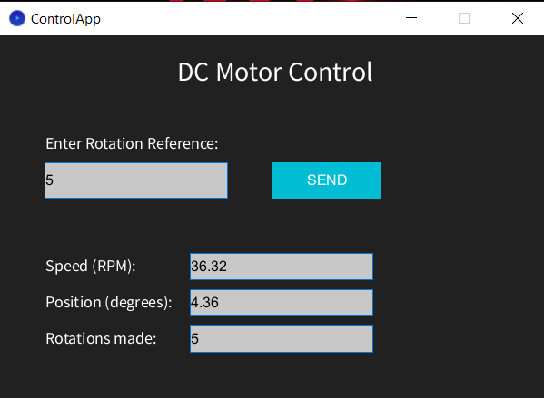

Figure 8. Refference of 5 rotation in the state of returning in the initial position
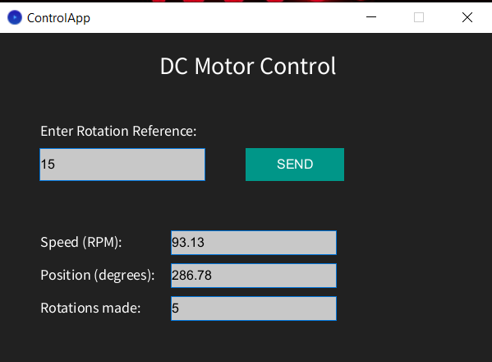
Figure 9. 15 rotations reference with 5 rotations made out of 15

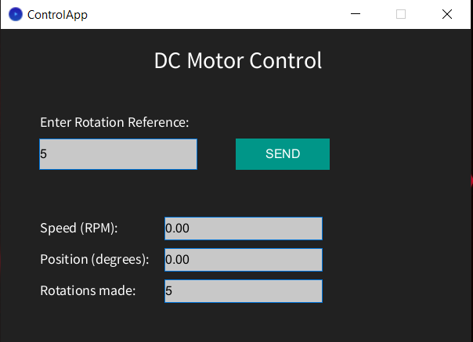
Figure 10. All sequences are done

Observations and Possible Improvements

- For more advanced control applications, it is recommended to use more powerful microcontrollers, higher-quality equipment, and sensors to achieve precise control. It was particularly observed that position control issues can arise due to the speed at which the program is iterated. The more complex the program, the slower the execution of the main loop, which can lead to sampling issues, thereby promoting system instability or maintaining a sustained oscillatory regime..

- Regarding speed calculation, erroneous speed readings were occasionally observed due to unwanted signal noise. Therefore, a Low Pass Filter can be added, implemented in the form of a recursive equation with a cutoff frequency, for this application, of 5-10 Hz:
$$H_{LPF}=\frac{2πω_{t}}{s+2πω_{t}}$$
where $ω_{t}$ is the cutoff angular frequency.
This function can, therefore, be discretized with a suitable sampling period, and the recursive equation is implemented in the discrete domain..

- The implementation of the PID controller was done by simply applying its general formula to the given process. However, a more precise controller design involves clearly identifying a model of the process to be controlled and applying one of the conventional design methods (Ziegler-Nichols, Cohen-Coon, Guillemin-Truxal, etc.).

- The implementation of speed control in the user interface proved to be challenging, as it required transmitting both the reference rotation values (discrete values sent after each completed execution) and the PWM signal values (continuously transmitted at each program iteration). Since the transmission methods were different through the same serial monitor, there were conflicts regarding value updates, resulting in very high delays and poor performance. Therefore, speed control remains to be managed through buttons.

Bibliography

- Arduino Documentation. (2025). Arduino Reference Guide.
https://www.arduino.cc/reference/en/
- Processing Documentation. (2025). Processing Language Reference
https://processing.org/reference/
- Arduino Forums
https://forum.arduino.cc/

